1. **Create Virtual Machine and Install IIS Server in windows VM, and Apache Server in linux using ARM and Bicep. Configure the below task using ARM, Bicep: Virtual Networking Peering B/W two Vnets.**

**Ans:**

* **Step 1: Create the ARM template file:**

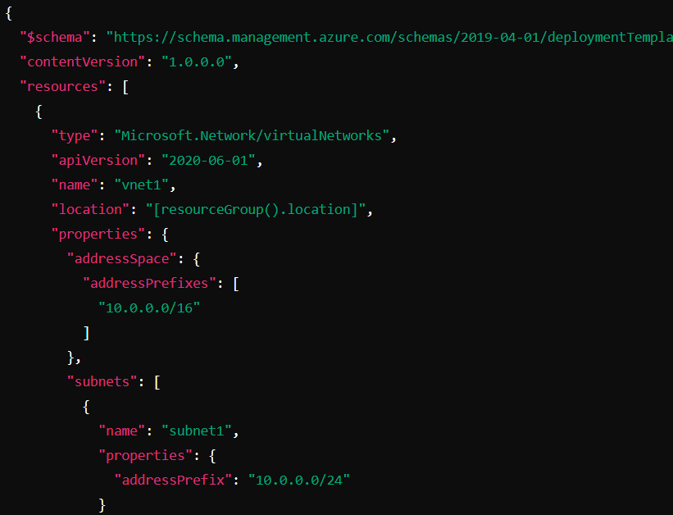

* **Step 2: Deploy the ARM template:**



* **Step 3: Create the Bicep file:**

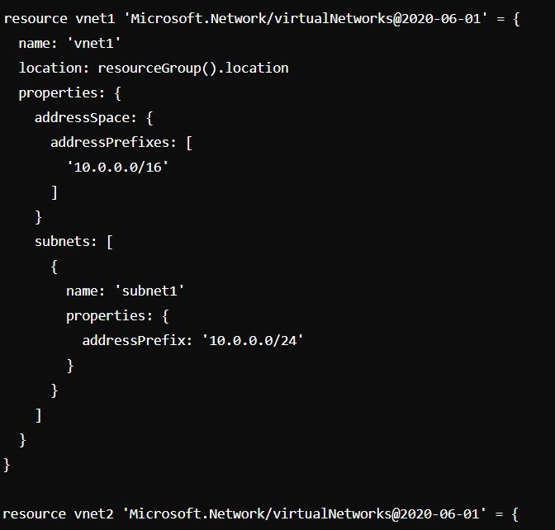

* **Step 4:** **Open Azure CLI or PowerShell and run the following command to deploy the Bicep file.** .
* **Step 5: Create Virtual Networks:**
* Create subnets within each virtual network.
* Create Network Interfaces:
* Create network interfaces for each VM and associate them with the respective subnets.
* Create Virtual Machines:
* Define a Windows VM (winVM) and a Linux VM (linuxVM).
* Install IIS on Windows VM:
* Use CustomScriptExtension to install IIS.
* Install Apache on Linux VM:
* Use CustomScriptExtension to install Apache.
* Set Up Vnet Peering:
* Configure virtual network peering between vnet1 and vnet2.